32.40: a) The change in the momentum vector determines 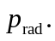 If  is the fraction absorbed, 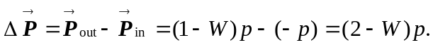Here, 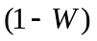is the fraction reflected. The positive direction was chosen in the direction of reflection. p is the magnitude of the incoming momentum. With Eq. 32.31, and taking the average, we get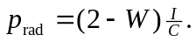 Be careful not to confuse p, the momentum of the incoming wave, with 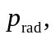 the radiation pressure.
b) (i) totally absorbing 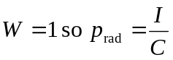
(ii) totally reflecting 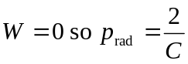
These are just equations 32.32 and 32.33.
c)

